PostGreSql

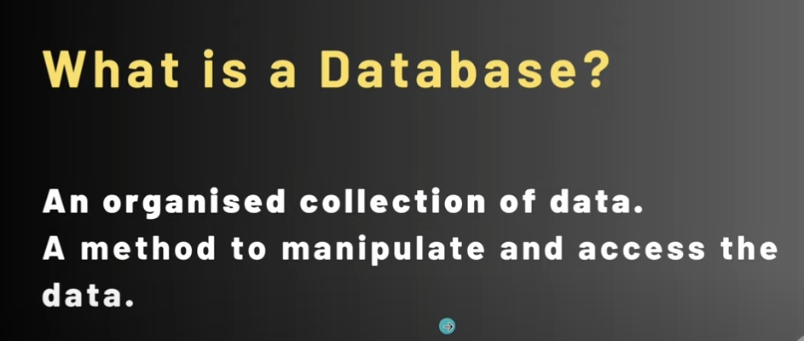

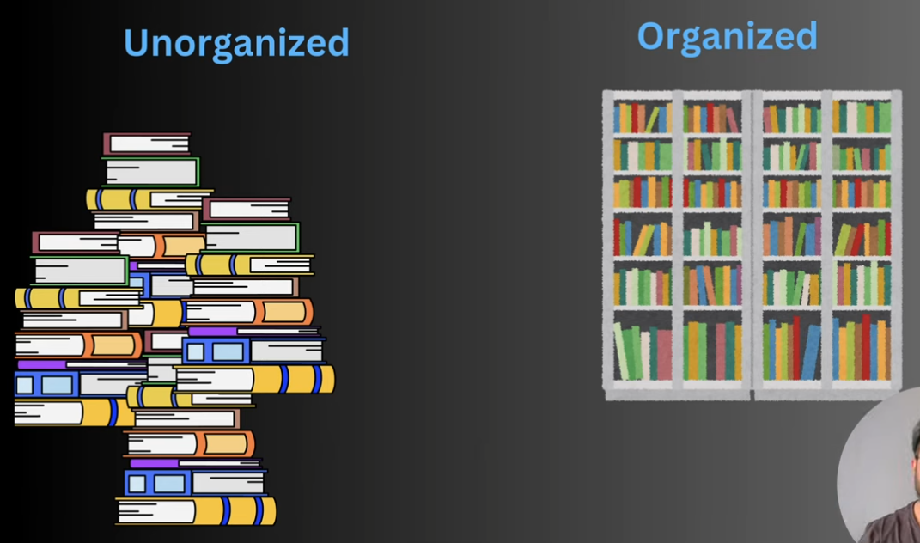

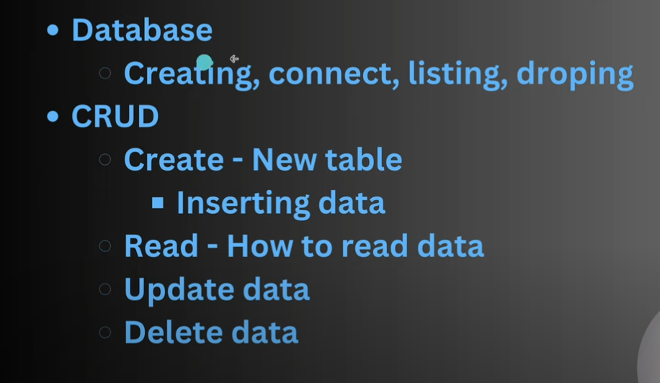

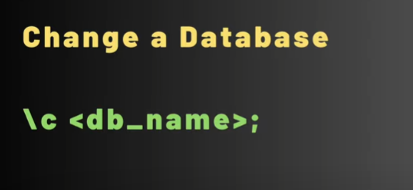

Changing from one database to another data base using

\c nameofthedatabase;

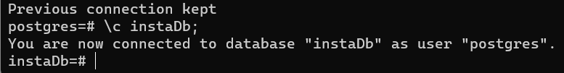

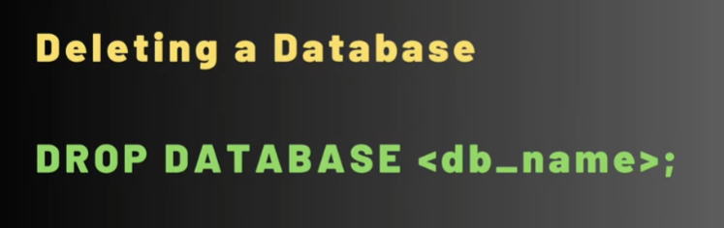

To delete a database;

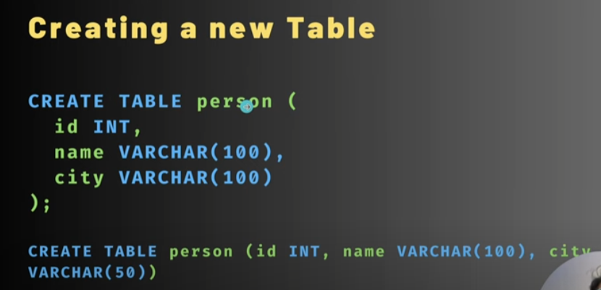

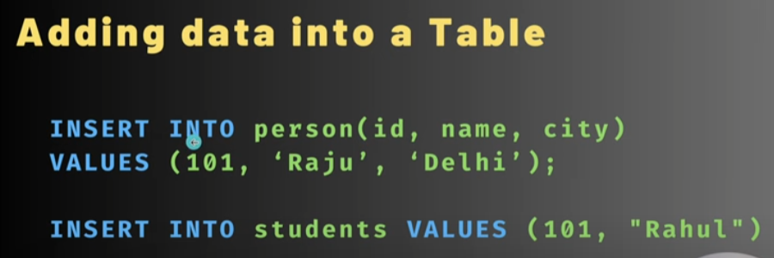

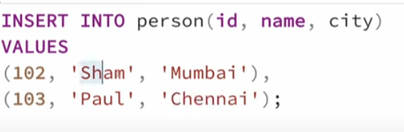

For multiple data.

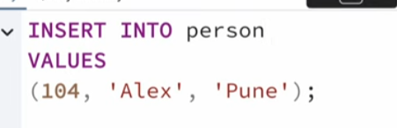

Without providing id name and city we can do in this type also.

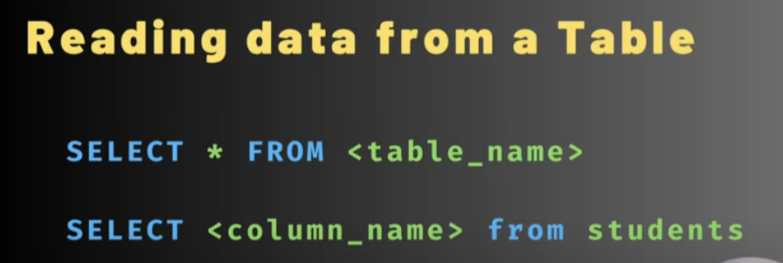

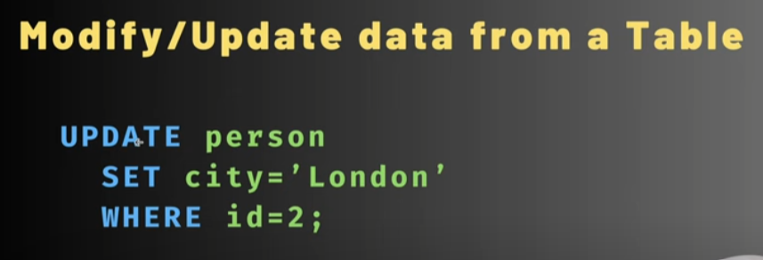



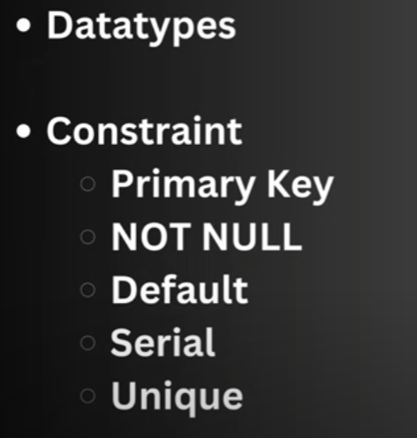

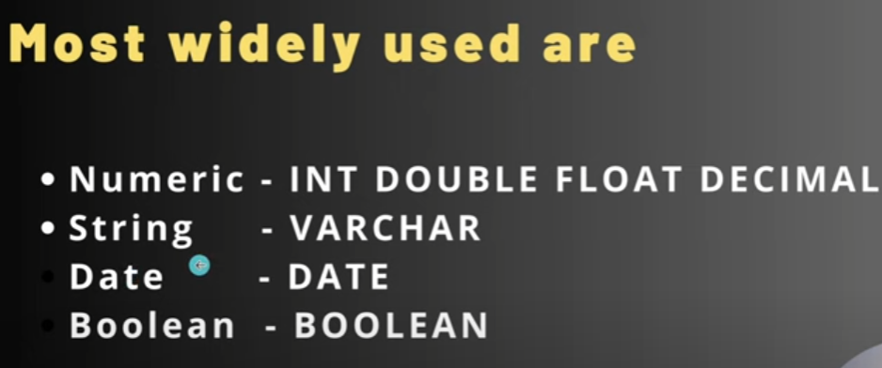

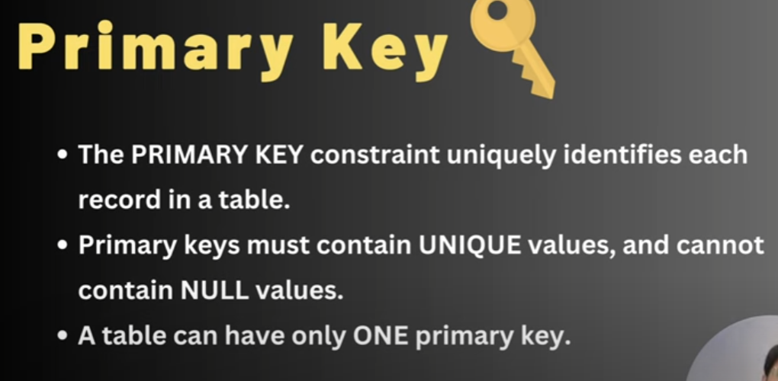

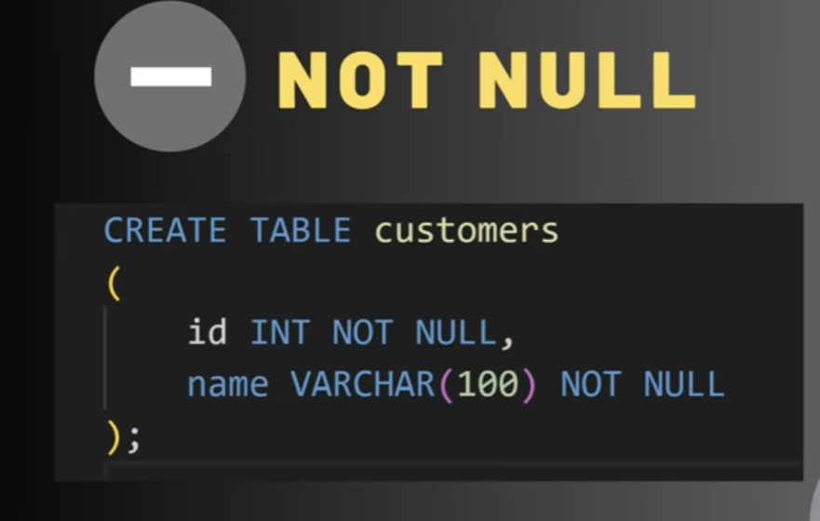

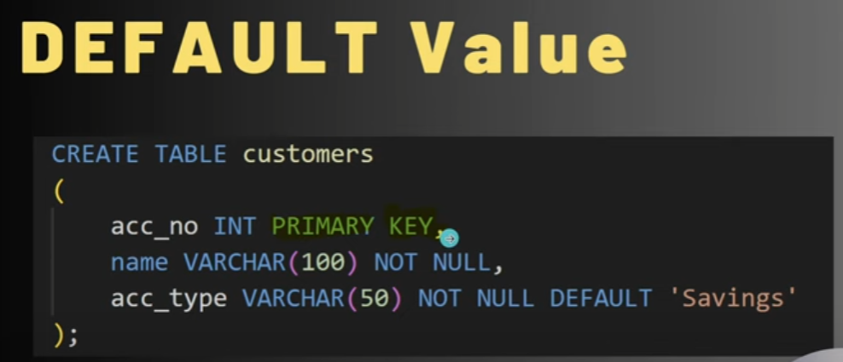

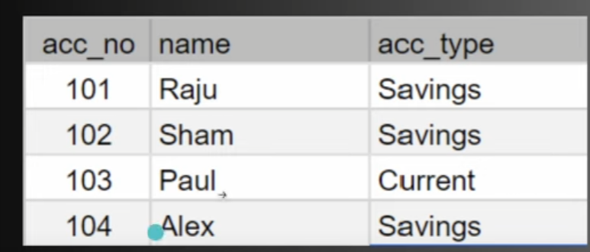

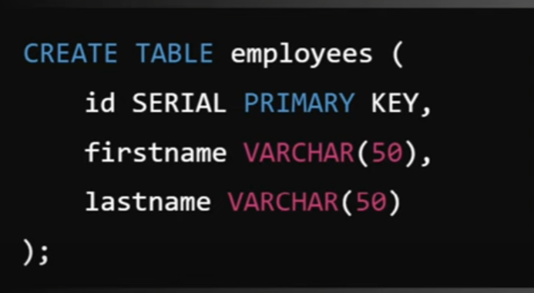

For auto increment Serial keyword is used .

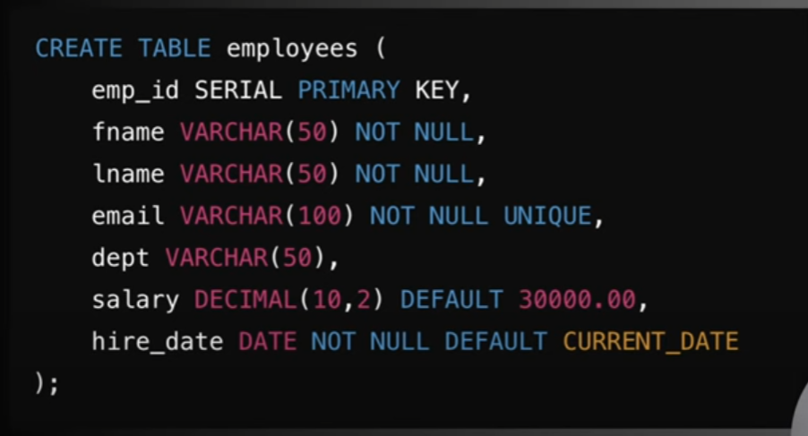

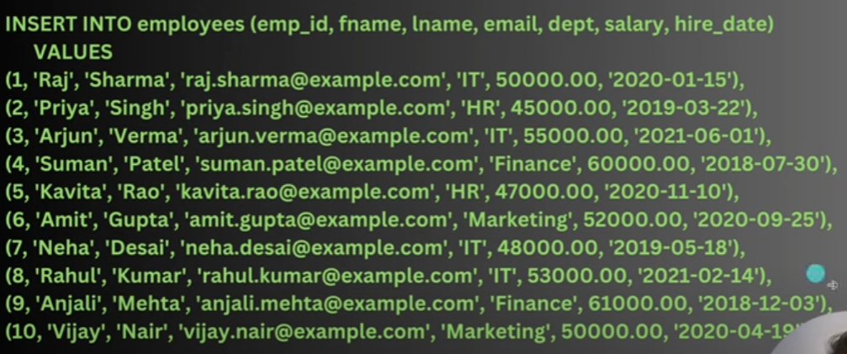

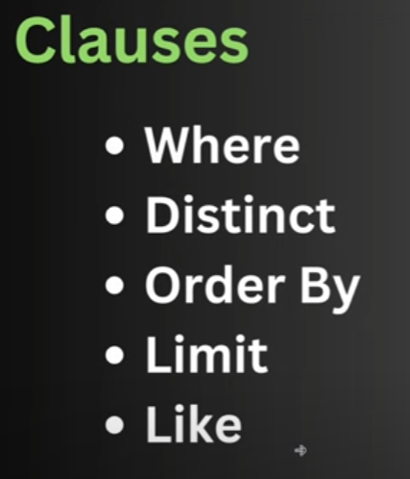

Select * from person where emp_id=5;

This will show only the data of 5th employee .

Select * from employees where salary >= 50000;

It will show the list whose salary is greater than 50000;

Select * from employee where dept=”Hr” or dept=”finance”;

It will show the data whose department is hr or finance .

Select * from employee where dept=’It” and salary > 50000;

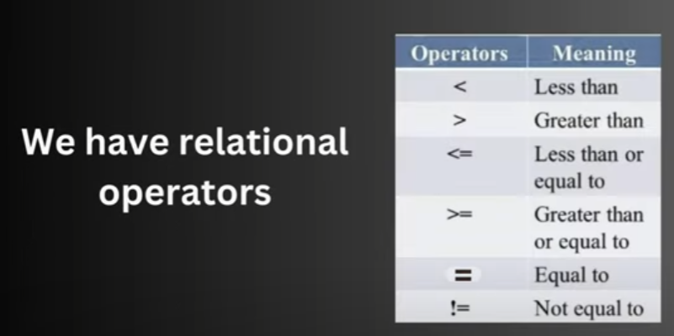





If we want to use more or condition then we can simply write ass in operator.

Select * from employees where dept NotIn (‘it’ , ‘hr’, ‘finance’);

It will show the data whose dept is not it , hr,finance and rest of the data it will shor like for hr and other it will show.

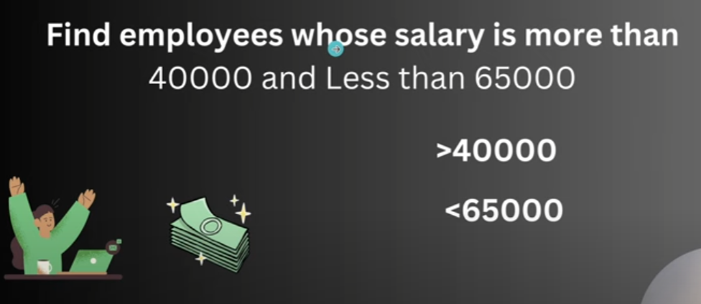





To findout the unique value only and not duplicate values.

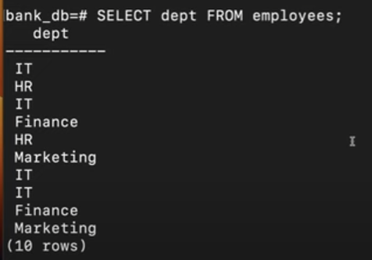ther is it 4 tims

Hr is 2 time

Finance is 2 and marketing is 2 time but we have only needed unique value then .

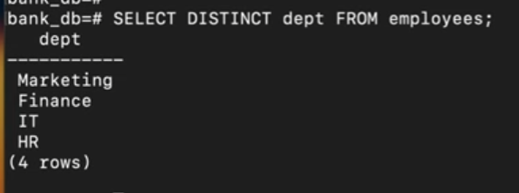

Sorting of the column;

Select * from employees order by fname ;

It will show the table in ascending order of fname;

For reverse order

Select * from employees order by fname desc;

It wil reverse the order of table in decreasing order;

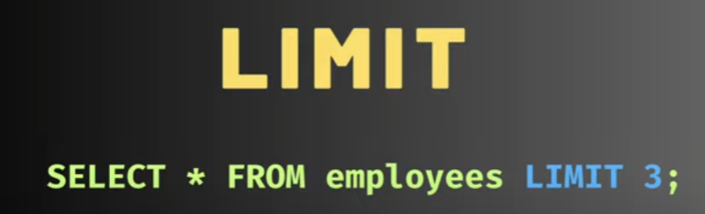

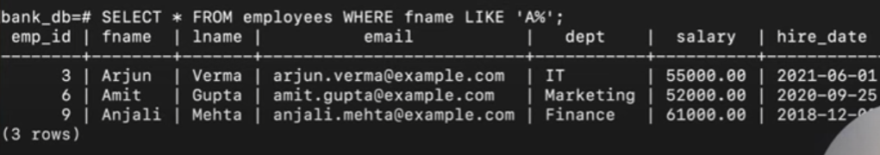

The employess whose data nameis start from character A and soo on.

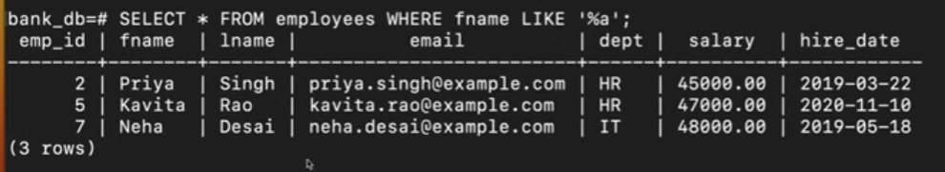

Last characteris a like in Priya last word is a .

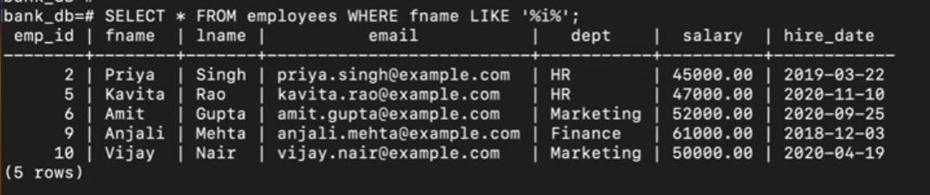

In between there is I present there .

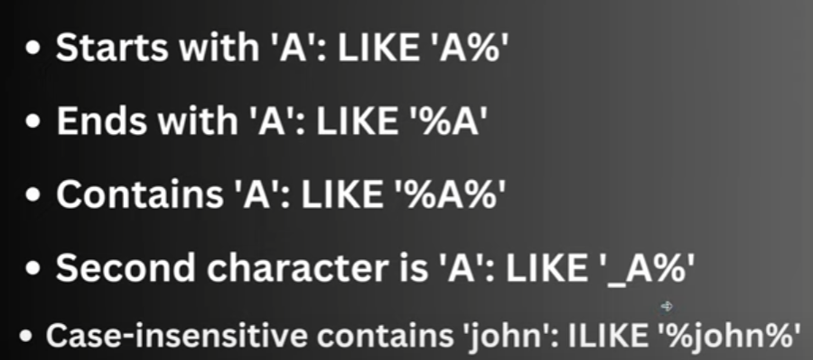

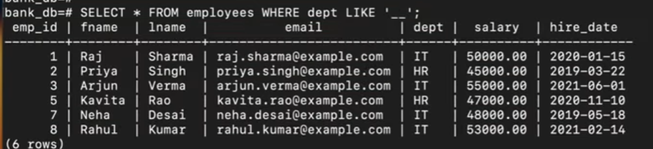

Only two character is present.



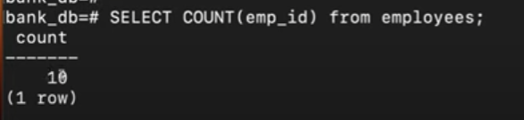

Total no of employee it will count .

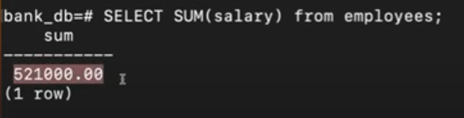

Total sum of the salary coulam

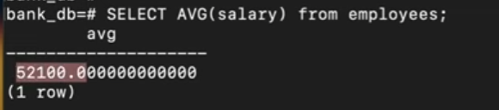

.avg of the salary.

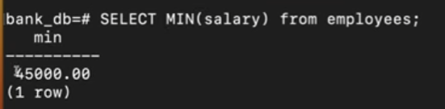

Minimum salary how much we are providing.

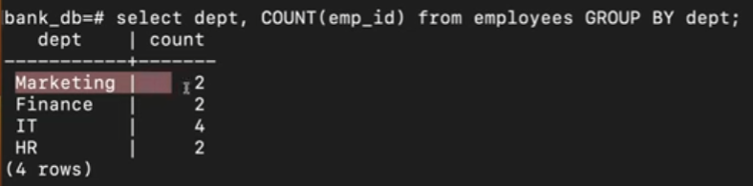

To make group of each department .

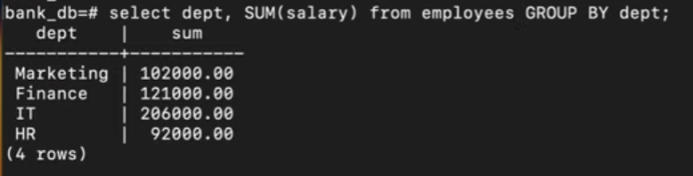

String Function

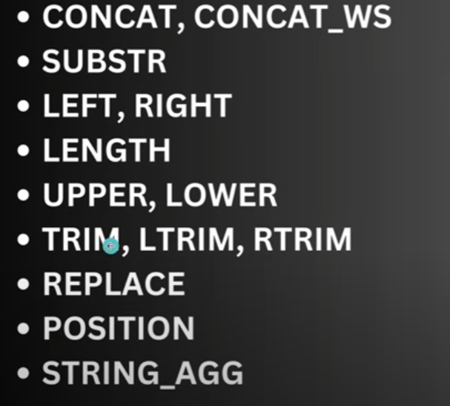

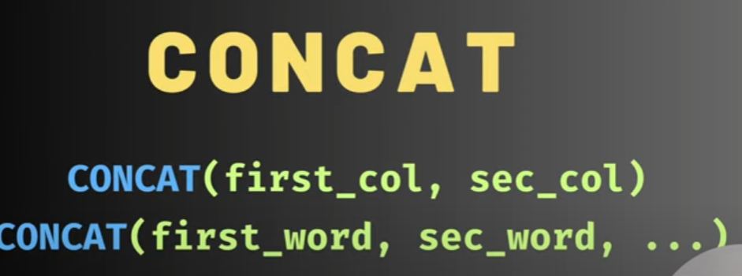

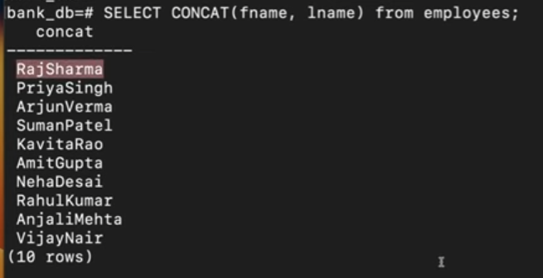

100 page of postgre sql